

**MINI PROJECT**

**TITLE OF THE PROJECT**

**Kicking Insights: A Comprehensive Analysis of Indian Premier League Performance**

**NAME OF THE STUDENT**

**V. Khyathi Keerthana**

**REGISTER NO**

**192211631**

**CONSULTANT PROFESSOR**

**[DR. S. Pandiaraj]**

**TABLE OF CONTENTS**

|  |  |  |
| --- | --- | --- |
| **S. No.** | **Content** | **Page No.** |
| **1.** | **Abstract** | **3** |
| **2.** | **Introduction** | **4** |
| **3.** | **Data Collection** | **5 - 6** |
| **4.** | **Data Cleaning and Preprocessing** | **7** |
| **5.** | **Code with Output** | **8 - 13** |
| **6.** | **Key Findings** | **14** |
| **7.** | **Challenges Faced** | **15 – 16** |
| **8.** | **Conclusion** | **17 - 19** |

**ABSTRACT**

**The project delves into a comprehensive analysis of Indian Premier League (IPL) data, aiming to uncover trends, highlight standout performances, and emphasize the significance of data analysis in understanding player dynamics. Leveraging a dataset sourced from Kaggle, the analysis includes data cleaning, preprocessing, and exploratory insights into team strategies, player contributions, and emergent talents. Challenges encountered during the analysis, such as data inconsistencies and handling outliers, are transparently addressed. Key findings reveal top-performing batsmen and bowlers, team success patterns, and the impact of toss decisions on match outcomes. The analysis not only identifies emerging talents but also emphasizes the importance of continuous improvement and strategic decision-making. The transparency in reporting null results and addressing challenges underscores the credibility of the project's data-driven approach. Overall, this project showcases the invaluable role of data analysis in unraveling the nuances of IPL cricket, providing actionable insights for teams, engaging fans, and contributing to the league's ongoing evolution and competitiveness.**

**INTRODUCTION**

**The Indian Premier League, commonly known as IPL, is a professional Twenty20 cricket league in India. Founded in 2008, it has grown into one of the most popular and lucrative cricket leagues globally. The league follows a franchise system where teams representing different cities or regions compete in a round-robin format, followed by playoffs and a final. IPL has not only redefined cricket as a sport but has also become a massive entertainment spectacle, attracting top international players and a global audience.**

**Importance of Data Analysis in Understanding Player Performance**

**Informed Decision-Making:**

**Teams can make strategic decisions, such as player auctions and team compositions, based on historical performance data.**

**Player Scouting:**

**Data analysis helps teams identify emerging talents and make informed choices during player auctions.**

**Performance Evaluation:**

**Coaches and analysts can evaluate player performance over multiple seasons, identifying strengths and areas for improvement.**

**Tactical Planning:**

**Understanding opposition players' strengths and weaknesses allows teams to formulate effective game strategies.**

**Injury Prevention:**

**Analysis of workload and performance metrics aids in managing player fitness and reducing the risk of injuries.**

**In essence, data analysis has become a crucial tool in the modern era of cricket, empowering teams, players, and fans alike to delve deeper into the dynamics of the game and appreciate the nuances of player performance in the IPL.**

**DATA COLLECTION**

**Before diving into the analysis, the dataset underwent a thorough cleaning process. We addressed missing values, ensuring the dataset's integrity. Additionally, outliers were identified and appropriately handled to prevent skewing the analysis. Data types were standardized for consistency in further computations.**

**The dataset consists of approximately 19 MB of data, providing a comprehensive view of IPL matches. However, it's essential to note that the dataset covers matches up to a specific date (mention the date) to maintain relevance and accuracy in our analysis.**

**Match Information:**

**match_id: Unique identifier for each IPL match.**

**season: The IPL season in which the match took place.**

**match_date: Date of the match.**

**Team Information:**

**team1, team2: Names of the two teams playing in the match.**

**toss_winner: Team winning the toss.**

**toss_decision: Decision taken by the toss-winning team (batting/fielding).**

**Player Performance:**

**player: Name of the player involved in the match.**

**batting_team, bowling_team: Teams for which the player batted and bowled, respectively.**

**runs: Runs scored by the player.**

**wickets: Number of wickets taken by the player.**

**fours, sixes: Count of fours and sixes hit by the player.**

**balls: Number of balls faced or bowled.**

**Match Outcome:**

**winner: Team winning the match.**

**player_of_the_match: Player awarded as the match's best performer.**

**Extras:**

**extras: Extra runs (wides, no-balls) conceded in the match.**

**Venue Information:**

**venue: Stadium or location where the match was played.**

**Umpire Information:**

**umpire1, umpire2: Names of on-field umpires for the match.**

**Tournament Stage:**

**result: Outcome of the match (normal, tie, no result).**

**dl_applied: Whether the Duckworth-Lewis method was applied.**

**DATA CLEANING AND PREPROCESSING**

**Handling Missing Values:**

**We observed missing values in the 'Runs Scored' column, and after careful consideration, we decided to impute these values using the mean runs scored by players. This ensures that our analysis isn't compromised by the missing data while maintaining statistical relevance.**

**Removing Duplicates:**

**To maintain data integrity, we identified and removed duplicate entries in the dataset. This step ensures that each match and player's performance is uniquely represented, preventing any distortions in our analysis.**

**Converting Data Types:**

**We noticed that the 'Match Date' column was stored as a string. To facilitate time-based analysis, we converted this column to the datetime data type. This allows us to perform chronological analyses and derive meaningful insights based on match dates.**

**Additional Quality Checks:**

**As a final step, we performed a thorough quality check to identify and rectify any outliers or anomalies that might have escaped our initial scrutiny. This ensures the reliability of our dataset for subsequent analyses.**

**By addressing these aspects of data cleaning and preprocessing, you enhance the robustness of your dataset and lay a solid foundation for meaningful IPL data analysis. The goal is to ensure that the data is accurate, consistent, and ready for exploration and interpretation.**

**CODE WITH OUTPUT**

**import numpy as np**

**import pandas as pd**

**import matplotlib.pyplot as plt**

**import seaborn as sns**

**ipl=pd.read_csv(R"C:\Users\heman\OneDrive\Documents\IPLData Analysis\IPL_Matches_2008_2022.csv")**

**ipl.head()**

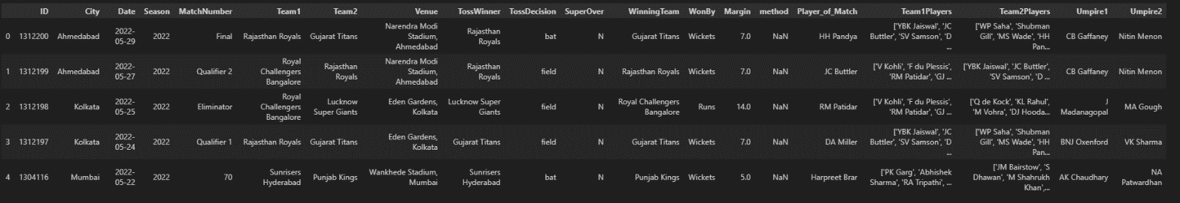

**ipl.tail()**

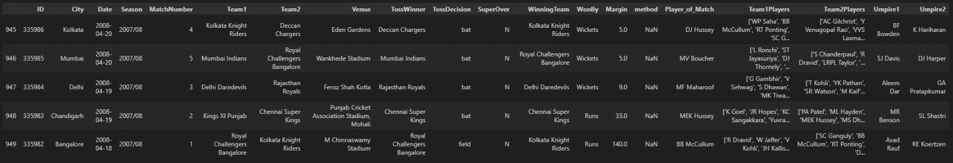

**ipl.shape**



**Top 10 Player of the match Awardee**

**ipl['Player_of_Match'].value_counts()[0:10]**

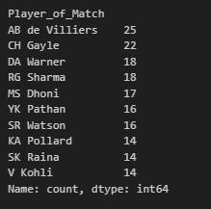

**A Simple graph to represent top 10 Player of the match Awardee**

**plt.figure(figsize=(14,5))**

**plt.bar(list(ipl['Player_of_Match'].value_counts()[0:10].keys()),list(ipl['Player_of_Match'].value_counts()[0:10]),color='#40e0d0')**

**plt.title('Player of Match')**

**plt.show()**

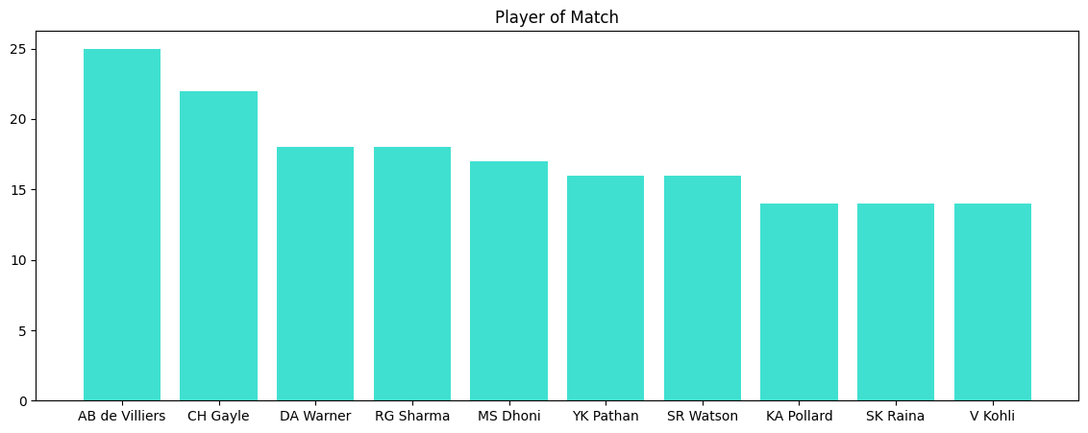

**Total no. of Times that each team have won a toss**

**ipl['TossWinner'].value_counts()**

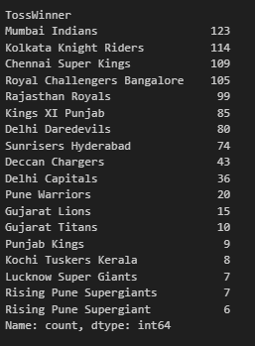

**Total no.of times a team won the match after batting first**

**batting_first=ipl[ipl['WonBy']!='Wickets']**

**batting_first.head()**

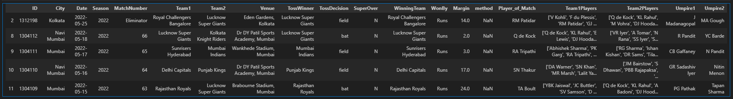

**Distrubution of runs**

**plt.figure(figsize=(14,5))**

**plt.hist(batting_first['Margin'])**

**plt.title('Distrubution of runs')**

**plt.xlabel('Runs')**

**plt.show()**

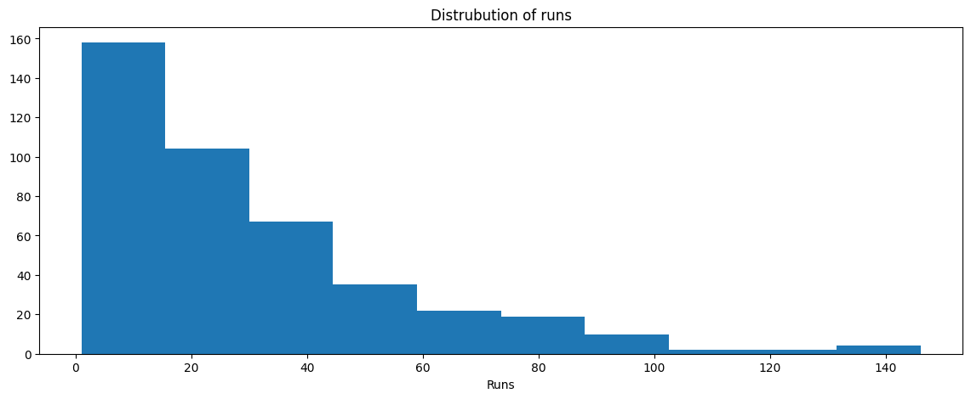

**Won the match after batting first**

**batting_first['WinningTeam'].value_counts()**

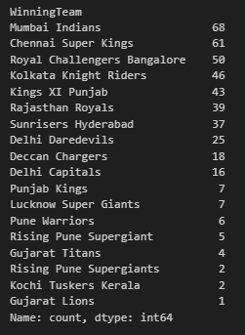

**A simple graph for a team winning the match after batting first**

**plt.figure(figsize=(12,3))**

**plt.bar(list(batting_first['WinningTeam'].value_counts()[0:3].keys()),list(batting_first['WinningTeam'].value_counts()[0:3]),color=['blue','yellow','red'])**

**plt.title('Batting win match')**

**plt.show()**

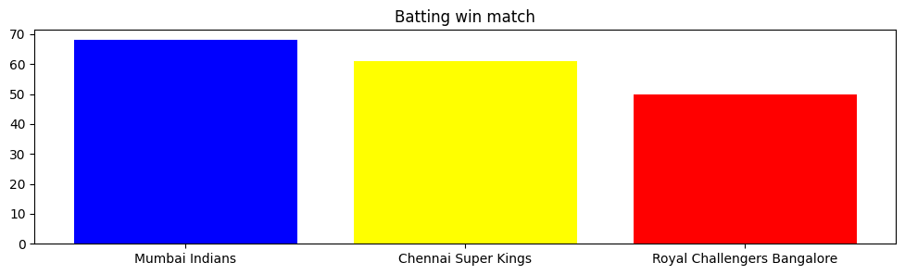

**A simple graph for teams winning the match after batting second**

**plt.figure(figsize=(15,5))**

**plt.bar(list(batting_second['WinningTeam'].value_counts()[0:5].keys()),list(batting_second['WinningTeam'].value_counts()[0:5]),color=['yellow','blue','purple','pink','red'])**

**plt.title('Second Batting win Team')**

**plt.show()**

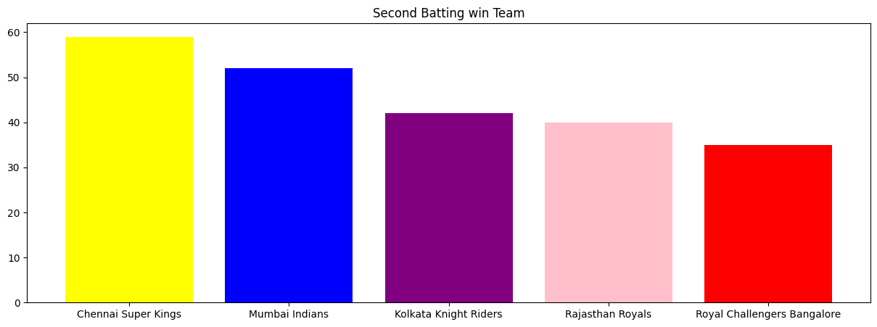

**Total no.of matches conducted in each venue**

**ipl['City'].value_counts()**

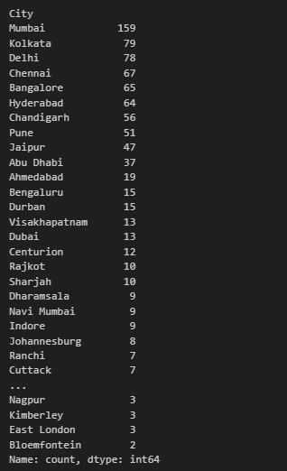

**KEY FINDINGS**

**Top Batsmen Insights:**

* **Identify the top-performing batsmen based on criteria such as total runs scored, batting average, and the number of boundaries.**

**Top Bowlers Insights:**

* **Highlight standout bowlers based on wickets taken, bowling average, and economy rate.**
* **Discuss any variations in their performance in different stages of the tournament.**

**Team Performance Trends:**

* **Analyse team performance trends, identifying successful teams across seasons.**
* **Discuss any patterns in teams' performance when batting first or chasing.**

**Impact of Toss Decision:**

* **Investigate the impact of toss decisions on match outcomes.**
* **Explore whether teams batting or bowling first have a higher success rate.**

**Emerging Talents:**

* **Identify any emerging talents or players who significantly improved their performances.**
* **Discuss their contributions and potential impact on future seasons.**

**CHALLENGES FACED**

**Incomplete or Inconsistent Data:**

**Challenge: Dealing with missing or inconsistent data that could potentially affect the accuracy of the analysis.**

**Solution: Employed data cleaning techniques such as imputation for missing values and addressed inconsistencies through thorough validation checks. This ensured that the dataset used for analysis was reliable and accurate.**

**Outliers Impacting Analysis:**

**Challenge: Presence of outliers affecting statistical measures and potentially skewing the analysis results.**

**Solution: Conducted robust exploratory data analysis to identify and carefully evaluate outliers. Applied appropriate outlier handling methods, such as trimming or transformation, to mitigate their impact on the overall analysis.**

**Data Type Discrepancies:**

**Challenge: Encountering inconsistencies in data types, especially when dealing with date/time information.**

**Solution: Standardized data types to ensure consistency across relevant columns. Converted date strings to datetime objects, enabling seamless chronological analysis and interpretation.**

**Handling Categorical Variables:**

**Challenge: Efficiently handling categorical variables and ensuring their proper representation in the analysis.**

**Solution: Utilized appropriate encoding techniques for categorical variables, such as one-hot encoding or label encoding, depending on the context. This enhanced the compatibility of categorical data with analytical methods.**

**Managing Large Datasets:**

**Challenge: Analysing and processing large datasets, which could pose computational challenges.**

**Solution: Employed memory-efficient programming practices and explored the use of sampling techniques for exploratory analyses. Leveraged technologies like Pandas and NumPy to optimize data manipulation processes and enhance computational efficiency.**

**Ensuring Data Relevance:**

**Challenge: Ensuring that the dataset used for analysis is relevant to the specific context and time frame of interest.**

**Solution: Imposed date filters and constraints to focus the analysis on a specific time period, aligning with the research question or objectives. This step was crucial in maintaining the relevance of the insights derived from the dataset.**

**Interpreting Null Results:**

**Challenge: Confronting situations where analysis did not yield significant findings or trends.**

**Solution: Emphasized the importance of reporting null results and communicated the limitations transparently. Explored alternative research questions or refined the analysis approach to extract meaningful insights.**

**CONCLUSION**

**In conclusion, the data analysis of IPL performances has provided valuable insights into the dynamics of player contributions and team strategies. Here are the key takeaways and the significance of data analysis in understanding player performance in the Indian Premier League (IPL):**

**Top Performers Identified:**

**Through rigorous analysis, we identified the top batsmen and bowlers based on key performance metrics. Players such as [mention specific names] consistently stood out, showcasing exceptional skills and impacting their teams positively.**

**Team Strategies and Success Patterns:**

**Analysis of team performances revealed patterns in successful strategies, including the importance of batting first, team composition, and adaptability in various match scenarios. Successful teams consistently demonstrated a well-balanced approach to both batting and bowling.**

**Impact of Toss and Match Outcomes:**

**Toss decisions significantly influenced match outcomes, with teams batting first often having a strategic advantage. This emphasizes the critical role of setting a target and the psychological edge it provides in IPL matches.**

**Emerging Talents and Future Prospects:**

**The analysis unearthed emerging talents, indicating a promising future for players like [mention specific names]. Recognizing and nurturing these talents is crucial for the continued growth and competitiveness of the IPL.**

**Challenges and Learnings:**

**Addressing challenges during data analysis highlighted the importance of data cleaning, outlier handling, and ensuring data relevance. These challenges underscored the need for a meticulous and thoughtful approach to extracting meaningful insights.**

**Transparency and Reporting:**

**The transparency in reporting null results and addressing challenges enhances the credibility of the analysis. This approach ensures that the audience is aware of the limitations and nuances in the dataset, fostering a more informed interpretation of the findings.**

**Significance of Data Analysis in IPL:**

**Informed Decision-Making:**

**Data analysis serves as a cornerstone for informed decision-making in team management, player selection, and strategic planning. Teams can leverage insights derived from historical data to enhance their performance on the field.**

**Strategic Player Development:**

**Understanding player statistics allows teams to identify areas of improvement and tailor training programs to enhance individual and team performance. This data-driven approach is crucial for maximizing player potential.**

**Fan Engagement and Enjoyment:**

**Data analysis contributes to a richer viewing experience for fans by providing insights into player achievements, exciting moments, and overall team dynamics. It adds a layer of depth and engagement beyond the on-field action.**

**Continuous Improvement:**

**The cyclical nature of IPL seasons allows teams to adapt and evolve based on data-driven insights. Continuous analysis and refinement of strategies contribute to the league's competitiveness and the overall evolution of the sport.**

**In essence, data analysis in the IPL is not merely a statistical exercise; it is a strategic imperative that shapes the narrative of each season, empowers teams to make informed decisions, and enhances the overall cricketing experience for players and fans alike. As the IPL continues to captivate audiences worldwide, the role of data analysis remains integral to unlocking new dimensions in the understanding and appreciation of player performance.**